Assignment 12

### Instructions

* Include necessary validation wherever getting user input and use Regular expressions
* Use JSON for storing and retrieving data
* Please follow all the standards and naming conventions

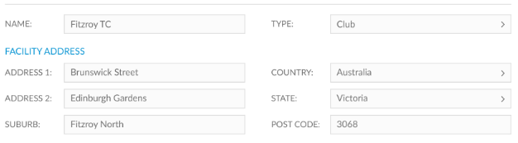

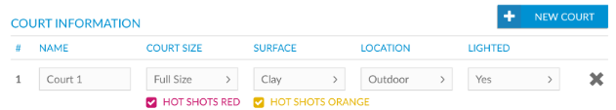

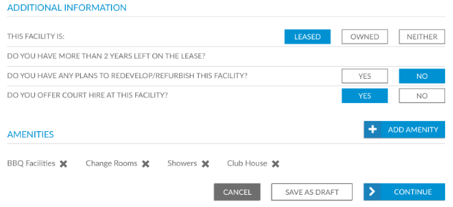

Following are the data points for facility details

|  |  |
| --- | --- |
| **Field** | **Description** |
| Name | Text input |
| Type | Dropdown input |
| Address1 | Text input |
| Address2 | Dropdown input |
| Suburb | text input |
| Country | Dropdown input |
| State | Dropdown input |
| Post Code | Text input |
| Facility property type | Leased/Owned/Neither |
| MoreThan2YearLease | Boolean input |
| Refurbish Plan | Boolean input |
| Offer Court Hire | Boolean input |
| Amenities | Multiple selection shown as pop-up and ability to remove amenities by clicking ‘x’ near it |
| Court Information | Information given below |

User should be able to add, edit and delete facility details

Following are the data points for Court information

|  |  |
| --- | --- |
| **Field** | **Description** |
| Name | Text input |
| Court Size | Dropdown input |
| Surface | Text input |
| Location | Dropdown input |
| Lighted | text input |
| Hot shots red | Checkbox |
| Hot shots orange | Checkbox |